Date



Smart Room Application

Team 2

Nuray Seker, Elma Buljina, Abir Sikder, Stefan Pilgerstorfer

Project  
documentation

Table of Contents

1. Introduction 3

2. Management Perspective 3

3. User Perspective 3

4. Developer Perspective 3

4.1. Design 3

4.1.1. Overview of the System 3

4.1.2. Important Design Decisions 3

4.2. Implementation 3

4.3. Code Quality 3

4.4. Testing 3

5. Installation guide 4

Version history

|  |  |  |  |
| --- | --- | --- | --- |
| Version | Date | Creator | Changes |
|  |  |  |  |
|  |  |  |  |
|  |  |  |  |
|  |  |  |  |

Table 1: Version history

# Introduction

*Overview of the project and this document*

# Management Perspective

*Which of the requirements did you implement? Which teammate was responsible? and How many hours he/she expend implementing this? If any requirement has not been implemented, then, the team should provide explanations for each requirement*

# User Perspective

*How were the requirements implemented in the user interface? (Screenshots of the user interface and description of the functionality based on scenarios) How the users should use the system?*

# Developer Perspective

## Design

### Overview of the System

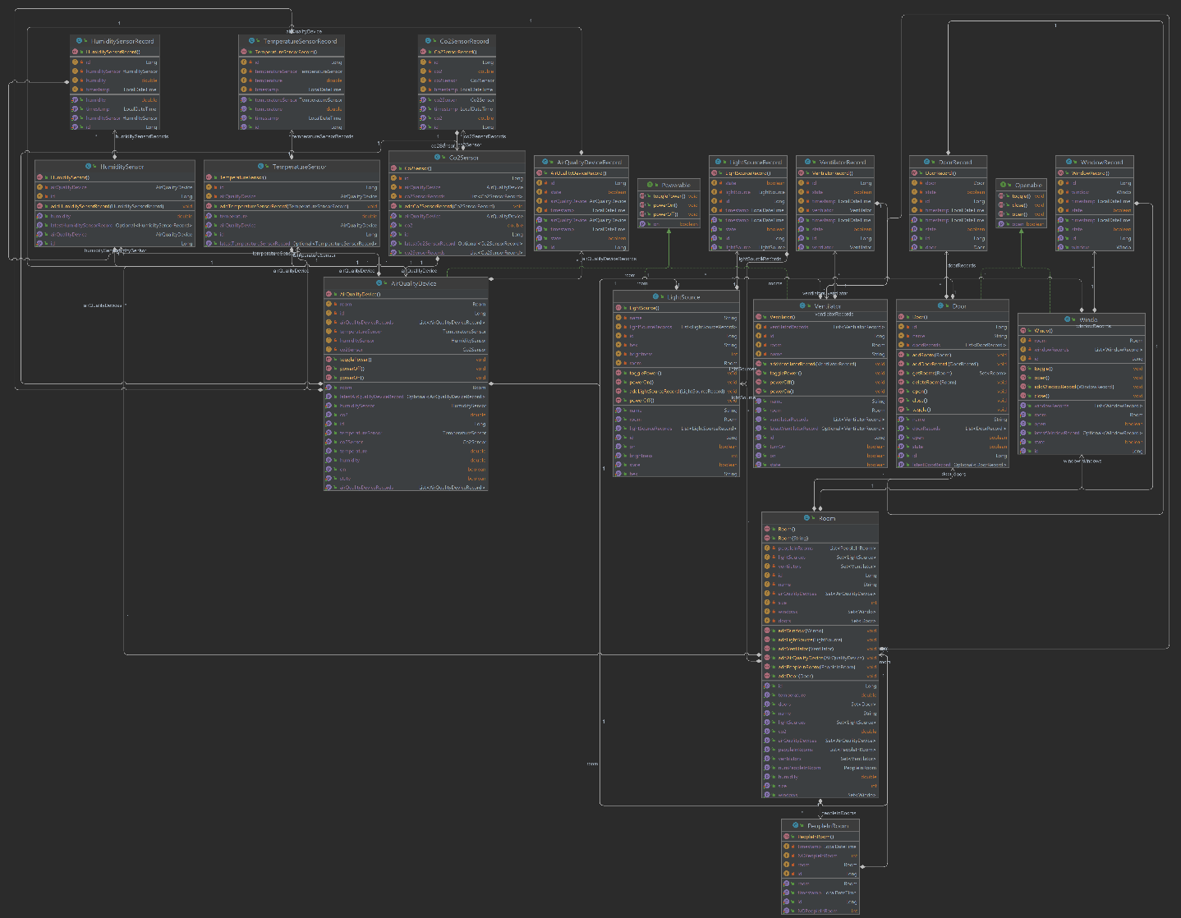*UML Diagram with explanations*

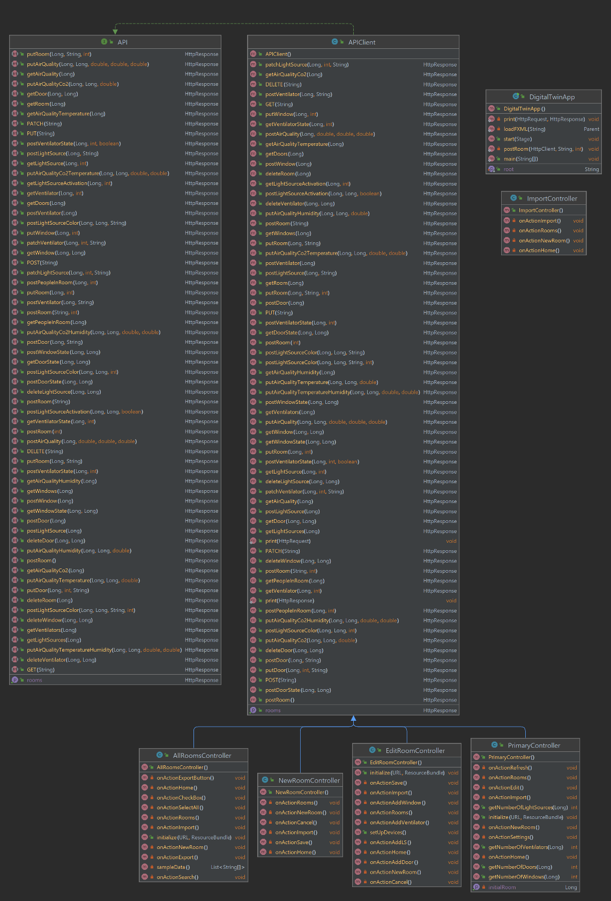

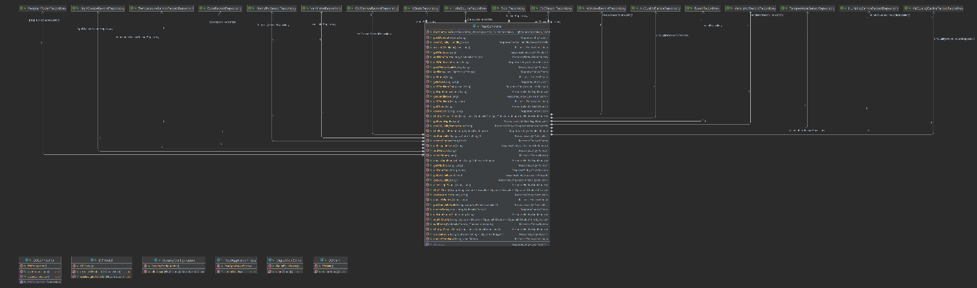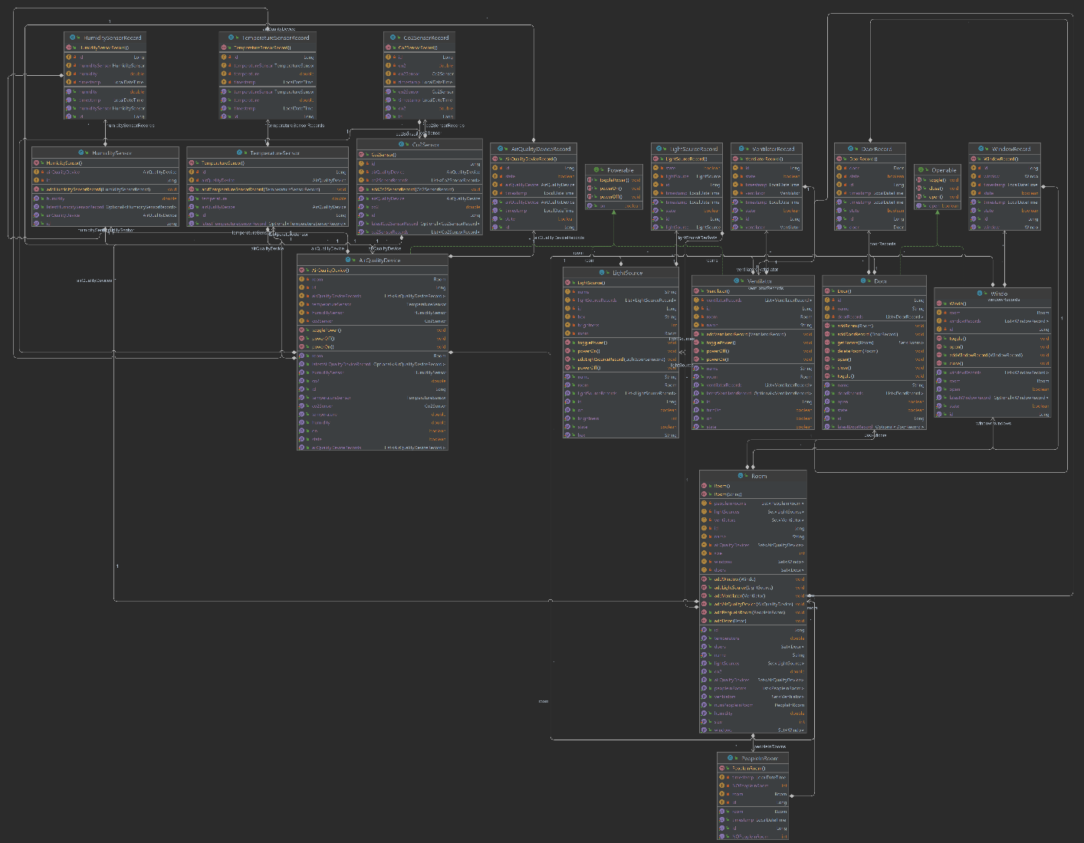

*Design patterns used (e.g. Model-View-Controller)*

### Important Design Decisions

*Description of the 3-5 most important design decisions in the following scheme*

*Decision:*

*Reason:*

*Considered Alternatives:*

*Assumptions:*

*Effect:*

## Implementation

*Description of the important aspects of the implementation (it can be described a few selected pieces of code), project structure, dependencies, libraries used, etc.*

## Code Quality

*Description of the use of PMD, description of the findings and which of them have been fixed.*

## Testing

*Overview of created JUnit tests (it can be described a few selected tests)*

*Description of the 3 selected tests according to the following pattern:*

|  |  |
| --- | --- |
| Test Case ID |  |
| Designed by |  |
| Execute on |  |
| Carried out by |  |
| Tested Requirement |  |
| Requirement |  |
| Test steps |  |
| Test data |  |
| Expected result |  |
| Post condition |  |
| Status |  |
| Comments |  |

# Installation guide

*Description of how to install and start the system*

*(Link to github)*

https://github.com/jku-win-se/teaching.ws22.prse.smartroom.Team2